E-COMMERCE SALES ANALYSIS PROJECT REPORT

Submitted To:
Skillbit Technologies

Submitted By:
Shreya Nikkam

Role: Data Analytics Intern

1. Introduction
This report presents the E-Commerce Sales Analysis project completed during my internship at Skillbit Technologies. This was my first project during the internship, aimed at applying data analytics concepts to a real-world retail dataset.

2. Project Objective
- To analyze online retail sales data.
- To identify revenue trends and customer purchasing patterns.
- To determine top-performing products.
- To create an interactive dashboard for business insights.

3. Tools & Technologies Used
- Microsoft Excel (Data Cleaning & Preparation)
- MySQL (Data Handling & Querying)
- Power BI (Dashboard Creation & Visualization)

4. Dataset Description
The dataset consists of online retail transactions including Invoice Number, Product Details, Quantity, Unit Price, Customer ID, Invoice Date, and Country. The dataset was cleaned and processed before performing analysis.

5. Data Preprocessing
- Removed missing and duplicate records.
- Created a Revenue column (Quantity × Unit Price).
- Extracted Month and Year from Invoice Date.
- Formatted data for dashboard visualization.

6. Key Performance Indicators (KPIs)
- Total Revenue
- Total Orders
- Total Customers
- Average Order Value (AOV)
- Total Quantity Sold

7. Dashboard Features
- Monthly Sales Trend Analysis
- Top 10 Products by Revenue
- Country-wise Revenue Distribution
- Interactive Filters and Slicers
- Custom Tooltip for Product Insights
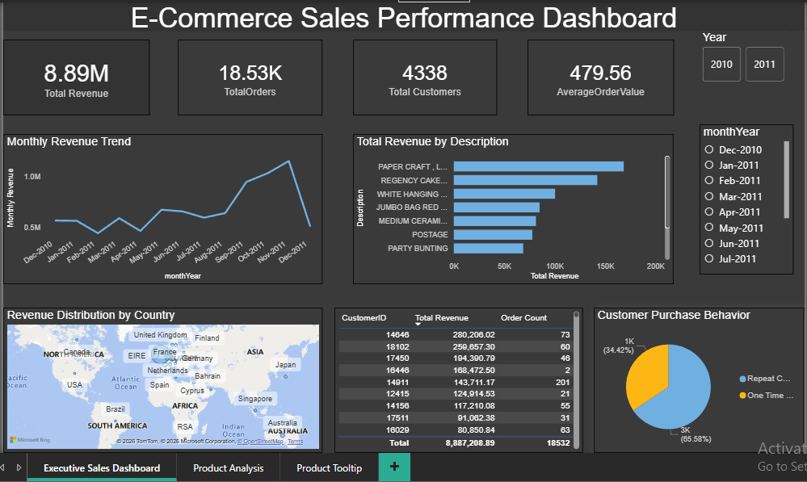

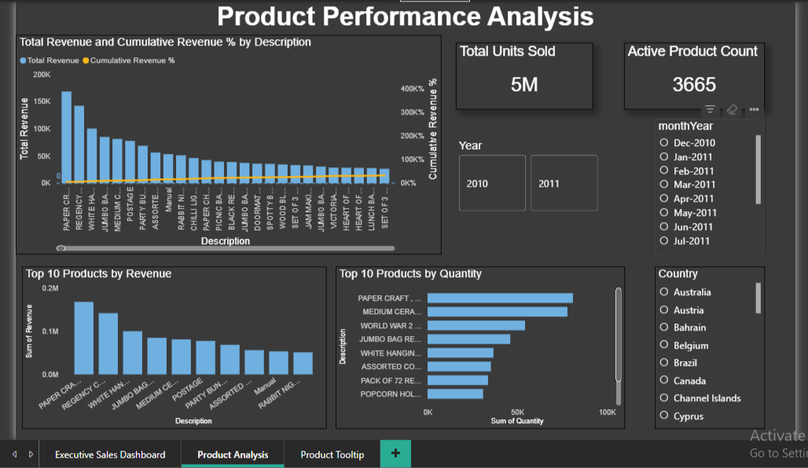

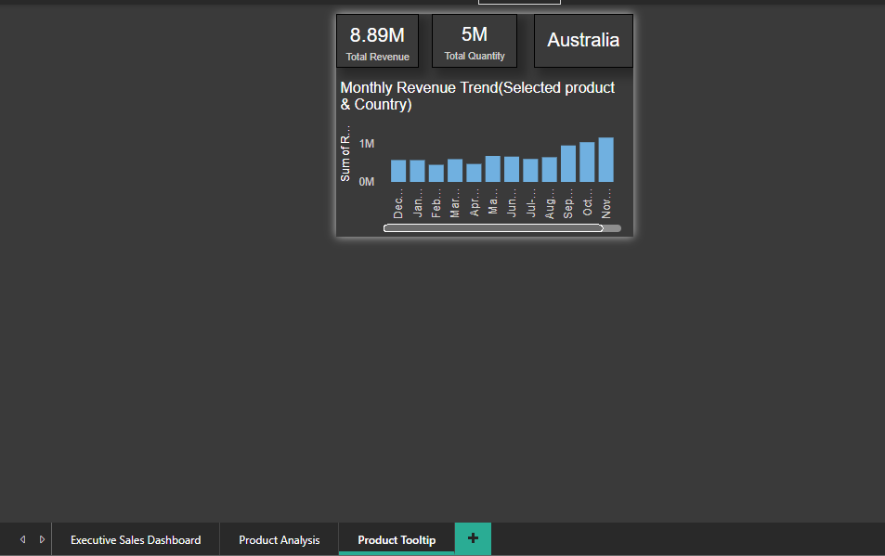

8. Key Insights
- A small percentage of products contribute to a major portion of total revenue.
- Sales show monthly variation indicating seasonal trends.
- Certain countries generate higher revenue compared to others.

9. Conclusion
This project helped me understand the complete data analytics workflow including data cleaning, transformation, KPI creation, and dashboard development. It strengthened my analytical thinking and visualization skills during my internship at Skillbit Technologies.

